**TULIPP**

**H2020-ICT-O4-2015**

**Grant Agreement n° 688403**

**D[X.X]: [Title of the Deliverable]**

**Lead Author: [Name and organisation]**

**with contributions from:**

|  |  |  |
| --- | --- | --- |
| **Organisation**  **no.** | **Organisation**  **name** | **Participant Name** |
|  | IOSB | Tobias Schuchert, Igor Tchouchenkov |
|  |  |  |
|  |  |  |

**Reviewers**

|  |  |  |
| --- | --- | --- |
| **Organisation**  **no.** | **Organisation**  **name** | **Participant Name** |
|  |  |  |
|  |  |  |
|  |  |  |

Document Description

|  |  |
| --- | --- |
| **Deliverable number** |  |
| **Deliverable title** |  |
| **Work Package** |  |
| **Deliverable nature** |  |
| **Dissemination level** |  |
| **Contractual delivery date** |  |
| **Actual delivery** |  |
| **Version** | v1.0 |

|  |  |  |
| --- | --- | --- |
|  | **Written by** | **Approved by** |
| Name  Signature |  |  |

Version history

|  |  |  |  |
| --- | --- | --- | --- |
| **Version** | **Date** | **Editors** | **Description** |
|  |  |  |  |
|  |  |  |  |
|  |  |  |  |
|  |  |  |  |
|  |  |  |  |
|  |  |  |  |

Abstract

[Describe briefly the deliverable content, the context and objectives of the deliverable toward the objectives of the WP. Explain, if needed, why the delivery has been delayed]

TABLE OF CONTENTS

[1 TITLE 1 7](#_Toc447099935)

[1.1 TITLE 2 7](#_Toc447099936)

[1.1.1 TITLE 3 7](#_Toc447099937)

[1.1.2 Title 7](#_Toc447099938)

[1.2 Title 7](#_Toc447099939)

[2 TITLE 4 7](#_Toc447099940)

[2.1 TITLE 5 7](#_Toc447099941)

[2.1.1 Title 7](#_Toc447099942)

LIST OF FIGURES

LIST OF TABLES

# TITLE 1

## TITLE 2

### TITLE 3

### Title

## Title

# Use case UAV

## Introduction

Most researches in image processing algorithms for unmanned aerial vehicles (UAVs) focus on two areas: pose estimation and obstacle/collision avoidance. Algorithms for pose estimation calculate the current 3D position and orientation of the UAV relative to immovable objects near to the UAV and, if needed and possible, also the global geographical coordinates. Obstacle detection is also based on 3D position of the UAV relative to other objects in direct environment. In contrast to pose estimation, the camera(s) for obstacle detection are not directed to the ground but in flight direction. For collision avoidance, current route and velocity of the UAV must be also taken into account.

There exist many algorithms with different kinds of hardware setups. Systems with multi- or depth -cameras simplify depth estimation, but sensor hardware is more expensive, heavier and more power consuming compared to systems with single or multi cameras. For single camera systems Visual SLAM (Simultaneous Localization and Mapping) or visual odometry algorithms are used. Some of these algorithms are already integrated in small size UAVs, but are limited in resolution and accuracy.

Both algorithms have to operate in real-time, meaning, that as small UAVs can cover over 30 meters per sec, obstacles should be detected at least 10 times/sec to ensure possible collision avoidance techniques.

The solution with stereo camera uses less complex algorithms and is more precise - that is very significant for small flying systems. Only benefit of one camera is the saving of the second camera, but because of small sizes (couple cm) and weights (10-20 g) of modern cameras it is no problem now, because the weight of UAVs in target group is at least 1 kilogram (normally 3-5 kg). The power consumption of such camera is few watts, what is almost negligible in comparison with the power consumption of a flying multicopter (at least 500 watt, normally over 1000 watt).

Most suitable algorithms for two cameras will be selected, re-designed and ported on embedded low-power Tulipp platform and validated on a UAV. It will enhance the performance and the autonomy of existing and future UAVs.

## Description

Obstacle detection is needed to avoid collisions with motionless or moving obstacles on the flight lane and is indispensable for autonomous flight. Currently typical velocities for rotating wing UAVs fly with velocities up to 20 m/s, i.e. 72 km/h (e.g. DJI Phantom 4). The stopping or obstacle avoidance manoeuver distance depends on several parameters. The most important parameter is the velocity, but also the type of the UAV and payload or the weather conditions play a role for collision avoidance. Typical distances for collision detection are in the range from 1 to 15 meters. The size of a dangerous obstacle is usually over 5 cm (Image 1 a), but in some cases obstacles with sizes of less than 2 cm can be also dangerous (Image 1 b-c).

|  |  |  |
| --- | --- | --- |
| P1020056.JPG | Fraun_6577.jpg | Halle_3.jpg |

a. b. c.

Image 1: Different obstacles in typical environments of UAVs

The field of view (FoV) of the camera is another important parameter for collision avoidance. In order to detect obstacles nearby and to find the way through complex environments we recommend a horizontal FoV of at least 90°. We approximate the minimum sensor resolution to detect an object with 5 cm size in a distance $d=5$ meter using cameras with $α=90°$ field of view by:

$$\tan\left(\frac{α}{2}\right)=\frac{x_{res}/2}{d}\left[m\right]⟺x_{res}=\tan\left(\frac{α}{2}\right)*d*2 \left[m\right]=\tan\left(\frac{α}{2}\right)*d*2*40 \left[pix\right]=400 [pix]$$

Hereby we assume that an object should have at least a width of 2 pixel for detection, i.e. 1 pixel equals to 2,5 cm in 5 meter distance. For robust collision avoidance, the resolution should be at least 2 times higher.

However, in the first step the goal is to reach real-time calculation of dense depth maps for an input image with a width of 640 x 480 pixel. The frequency of calculated depth images should reach 10 frames per second. Assuming a velocity of the UAV of 10 m/sec, the UAV moves 1 m per frame. If we cannot achieve these parameters with the TULIPP-platform parameters like max. speed of the UAV or minimum size of detected objects must be adapted.

The calculation above only sets the parameters for obstacle detection, but not for depth/distance estimation of this object. This distance is important in order to calculate an appropriate collision avoidance maneuver. In general, the wider the baseline between the two stereo cameras the larger is the distance where depth estimation of objects is possible. The drawback of wide baselines is that the process of finding correspondences gets more difficult. The distance in pixel between the position of an object in one input image to the position in the other input image is called disparity. If we assume, that the disparity d should be between two and 20 pixel in a distance z of two to twenty meters we can calculate the baseline b the two cameras should have according to:

$$\frac{z}{f}=\frac{b}{d} ⟺b=\frac{z*d}{f}=\frac{2000*2}{320}cm=12,5 cm$$

Where we assume a focal length f of: $\tan\left(\frac{α}{2}\right)=\frac{320 pixel}{f} ⟹f=\frac{320 pixel}{ \tan\left(\frac{α}{2}\right)}=320 pixel$

To plan a new trajectory around the obstacle, we have to calculate relevant 3D parameters (distance to the obstacle and its sizes).

The use case solution “collision avoidance” must support following functions:

1. Synchronized image acquisition of two cameras
2. Depth estimation from stereo images
3. Calculation of 3D environment model
4. Getting the current position and flying route from UAV control unit and transferring them into the 3D environment model
5. Detection of objects within the 3D model, which are on the current air route of the UAV and can cause a collision. The relevance of detected objects depends on different parameters, e.g. distance to the object, velocity of the UAV and size of the object.
6. Calculation of a new safe (free from obstacles) air route taking into account inaccuracies of the 3D model and possible variations of the UAV from the planned trajectory
7. Transfer of the new route to the UAV control unit

## Requirements

To support the solution, a *Tulipp instance must have* the following interfaces:

1. 2 camera interfaces (HDMI, USB or CameraLink) – Ethernet interface not suitable for the UAV use case because of latency constraints
2. Interface to the UAV control unit (USB or another serial bus)

These interfaces may have different implementations (different combinations using CPU, FPGA and operating systems are conceivable), but all of them must support real-time functionalities.

There are four common possibilities to implement the solution algorithm on the Tulipp platform:

1. Using main CPU (with co-processor, if available)
2. Using GPU
3. Using FPGA
4. Using any combination of components from 1- 3.

These possibilities must be compared taking into account Size, Weight and Power (SWaP) requirements and of course corresponding benefits (first of all the time needed to produce from video input and send a suitable output to a UAV control unit).

The available video exploitation software is provided in C/C++. Using OpenCV may help optimizing the code.

## Algorithms and software

For the real-time calculation of depth information from a stereo camera setup, the Semi-Global-Matching (SGM) algorithm [1] will be used. The following sections will give an overview how this algorithm works and how the reference code is run.

### A Semi-Global-Matching algorithm for stereo depth estimation

Looking at an object through a stereo camera setup, the one camera will observe the object at a different position than the other camera. Given the location and orientation of the cameras relative to each other, the distance of the object to the camera setup can be derived by measuring how the object is translated between the images of the two cameras (see Figure 1). This measuring requires a detection of the same objects in both images, which is done in a number of consecutive steps:

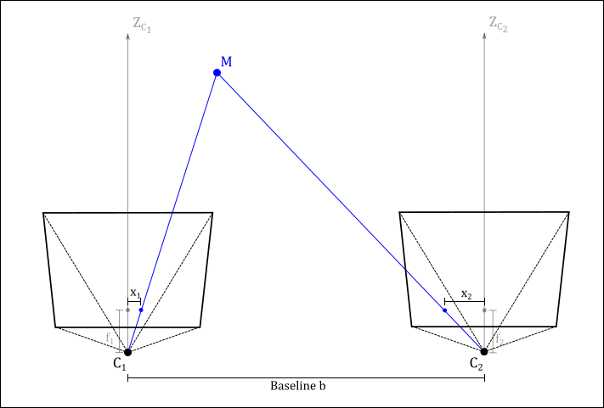

Figure 1: Exemplary stereo camera setup. Both cameras ($C_{1}\text{and }C_{2}$) are placed so that their optical axes ($Z_{C_{1}}\text{and }Z_{C_{2}}$) are parallel. The distance between both cameras is known as the baseline $b$. The scene point $M$ is observed by both cameras at different locations ($x_{1} \text{and }x_{2}$). The difference between both observations is called the disparity $d=|x_{1}-x_{2}|$  
.

**Step 1: Image rectification**

**A difficulty in the search for image correspondences in two or more images is that the objects can be located at arbitrary position which would require an exhaustive search over the whole image domain. Having an ideal stereo setup, where both cameras are identical and are mounted in such a way that their optical axes are parallel, the search for correspondences can be reduced to a solely horizontal direction. As such a setup is generally extremely hard to realize, one can transform input images before the depth estimation, so that they are aligned to each other and that the correspondence search can be restricted to a horizontal line. This process of transformation is called image *rectification*, and the results are two *rectified* images (**Figure 2**). The rectification is done for each image pair for which a depth estimation is to be performed. It requires information on the internal configuration of the cameras and their relative location on the stereo setup. The calibration that will yield this information can be precomputed and only needs to be done once.**

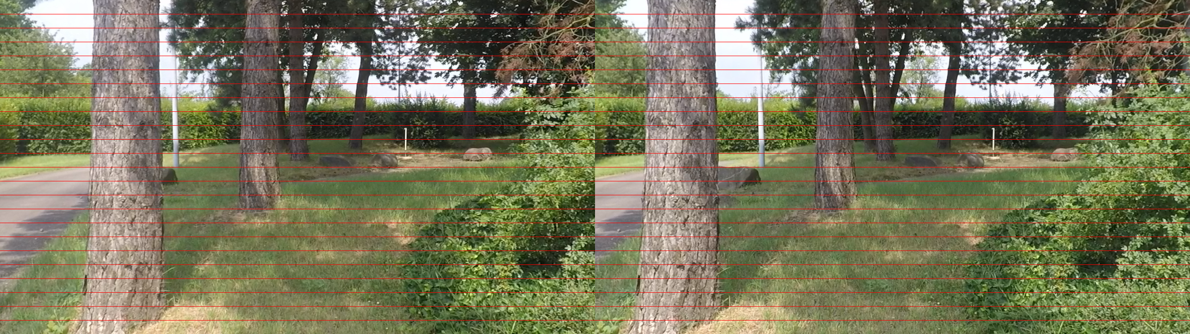

Figure 2: Exemplary rectified stereo imagery. Horizontal red lines help to show that the image are aligned in such a way that their image structures solely have a horizontal displacement.

**Step 2: Image preprocessing**

**To account for minor noise from the image sensor of the camera, the images are smoothed by convolving them with a Gaussian kernel. Depending on the amount of noise the size of the kernel can be varied, but caution should be takes as to not smooth the image to much which could lead to loss of detail.**

**Furthermore, depending on the limit in available processing time and the minimal size constraint of the object that are to be detected, the input images can be rescaled in order to reduce the amount of processing that is required.**

**Step 3: Correspondence search**

**The input for this step of the algorithm are two rectified and preprocessed images from the two cameras of the stereo setup. As explained earlier a distance measure of an object relative to the cameras, requires a measurement of the translation, the so called *disparity*, between the locations of appearance in both images. This is typically done by searching for similar pixels in both images along a horizontal line. Hereby the search range is limited by a minimum and maximum disparity, which can be set depending on the depth range which is to be scanned. The algorithm to search along a horizontal line is straight forward and is described by the following pseudo code:**

**for each pixel in image 1  
 - search along scanline in image 2 for similar pixel;**

**As** Figure 2 **shows, a relative translation of the camera to the right, results in a movement of the depicted object to the left. Therefore, if the image 1 refers to the image of the left camera, the search for correspondences can be restricted to the left side of the reference pixel.**

**The similarity of two pixels are measured by the minimization of a cost function. There exist a numerous number of appropriate cost functions, which work on different information an image pixel can provide. For simplicity we chose a cost function that solely compares the grayscale intensity values of two pixels by computing the absolute difference. To account for slight variations in the intensities we adopt an improvement done by Birchfield and Tomasi** [2] **using a linear interpolation of the intensity in the range of ± 0.5 pixels. The intermediate result of this correspondence search step is depicted in** Figure 3**.**

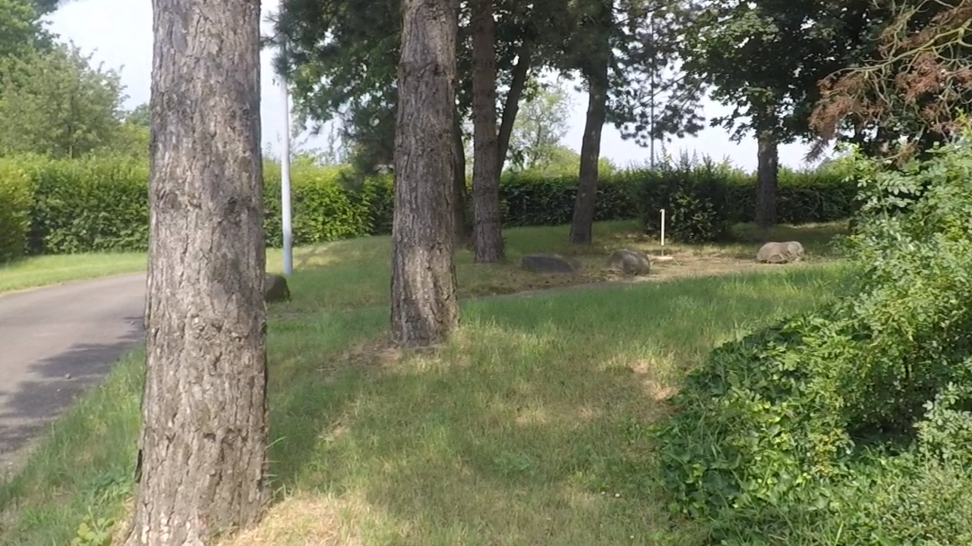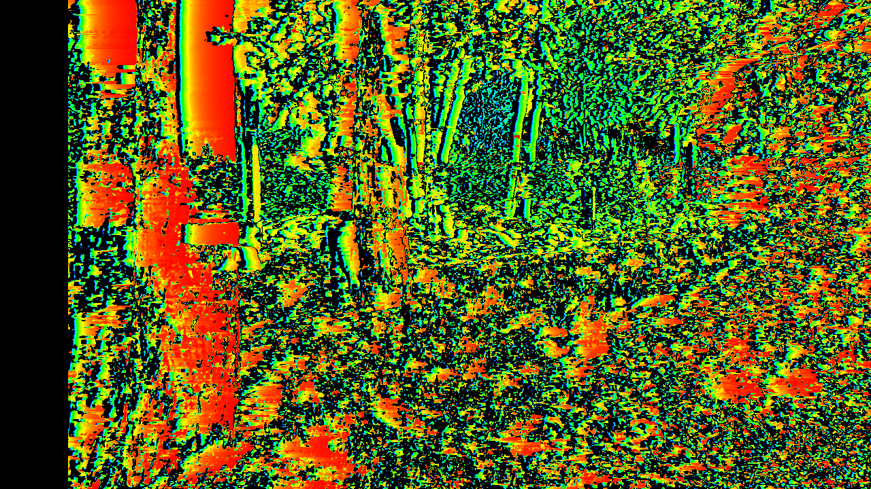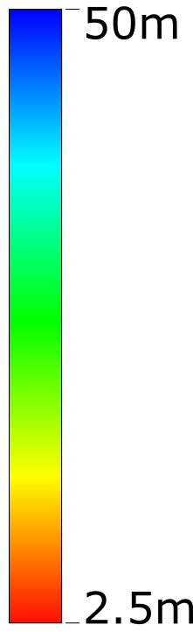

Figure 3: Intermediate result of the correspondence search. *Left:* Input image to which the depth image is computed. *Right:* Depth image computed without cost aggregation. The omission of aggregation leads to many ambiguities which results in an extremely inconsistent depth image.

**Step 4: Cost aggregation**

**As the result of the previous step shows, the simple search for correspondences along a scan line does not yield disparity measurements that are unique enough in order to derive the distance of an object from the camera. This because solely minimizing the absolute difference between pixels lead to ambiguities in areas which have similar appearances. To overcome this problem one can aggregate, i.e. sum up, the comparison costs in a defined neighbourhood. This improves the correspondence search as a larger number of pixels are compared with each other.**

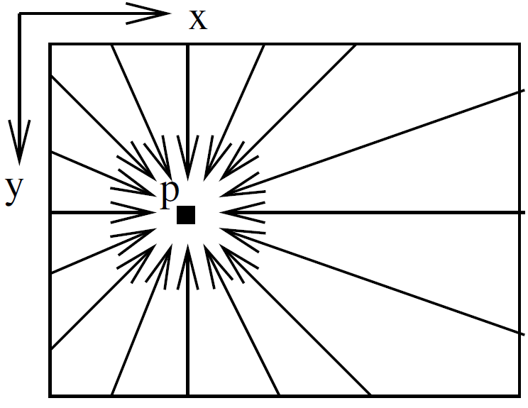

Figure 4: Illustration of path aggregation as part of the SGM algorithm [1]. The costs for each pixel $p$ are aggregated along concentric paths that centre in the $p$.

**In case of the SGM algorithm this cost aggregation is done along rays which centre in the current pixel that is compared as depicted in** Figure 4**. To reduce a variance in disparity for pixels that belong to the same object, a regularization is done within this cost aggregation. For each pixel that is to be aggregated a weight is multiplied to the cost depending on whether the disparity of the pixel varies more or less than 1 to the disparity of the reference pixel. If the disparity change is larger than ±1 a higher weight is premultiplied reducing the plausibility of the reference pixel to be a match. The mathematical formulation of this aggregation is described by:**

$$C_{aggr}\left(p\right)=C\left(p, D_{p}\right)+\sum_{q∈N_{p}}{\left\{\begin{aligned}φ_{1}⋅C\left(q,D_{q}\right) , if \left|D_{p}-D_{q}\right|=1 \\ φ_{2}⋅C\left(q,D_{q}\right) , else \end{aligned}\right.}$$

Equation 1: Semi-Global-Matching aggregation. The aggregated costs for pixel $p$ with disparity $D_{p}$ are computed by summing up the costs of pixel $C(p,D_{p})$ and the costs of the neighbouring pixels $q∈N_{p}$ on the concentric paths. The costs of the neighbouring pixels are weighted with different weights ($φ_{1}, φ_{2}$) depending on whether the disparity difference between pixel $p$ and $q$ ist equal or larger than $1$.

**The final disparity is selected finding the correspondence with the minimal aggregated cost. To improve the results, the disparity can be subpixel refined by fitting a parabola through the minimal and the two neighbouring costs, and computing its minimum.**

**Step 5: Disparity validation**

**Typical for stereo imagery both images will be affected by areas of occlusion. These areas occur when object in the foreground occlude objects in the background and thus will hide certain areas from the cameras. Unfortunately, these areas are not the same for both cameras, as they lock from different views onto the scene. Hence, it is not possible to calculate disparities for areas which are occluded in one of the two cameras.**

**To detect the such areas of occlusion one possibility is to compute two disparity maps, one for the left and one for the right image, and perform a consistency check between these disparity maps. This is done as follow:**

**for each pixel in disparity image 1  
 - move along horizontal line by given disparity and get   
 value from disparity image 2;  
 - if absolute value of both disparity does not differ   
 more than ±1, then disparity is valid;**

**Note that performing such a consistency check will drastically increase runtime as two disparity images are computed.**

**Step 6: Depth computation**

**Having computed the disparity image and thus acquiring pixel correspondences between the left and the right stereo image the depth can be computed for each pixel with valid disparity by simply triangulating the pixel correspondences (see** Figure 1**). Mathematically this is computed by**

$$Z=f⋅\frac{b}{d}$$

**The final result is depicted in** Figure 4**.**

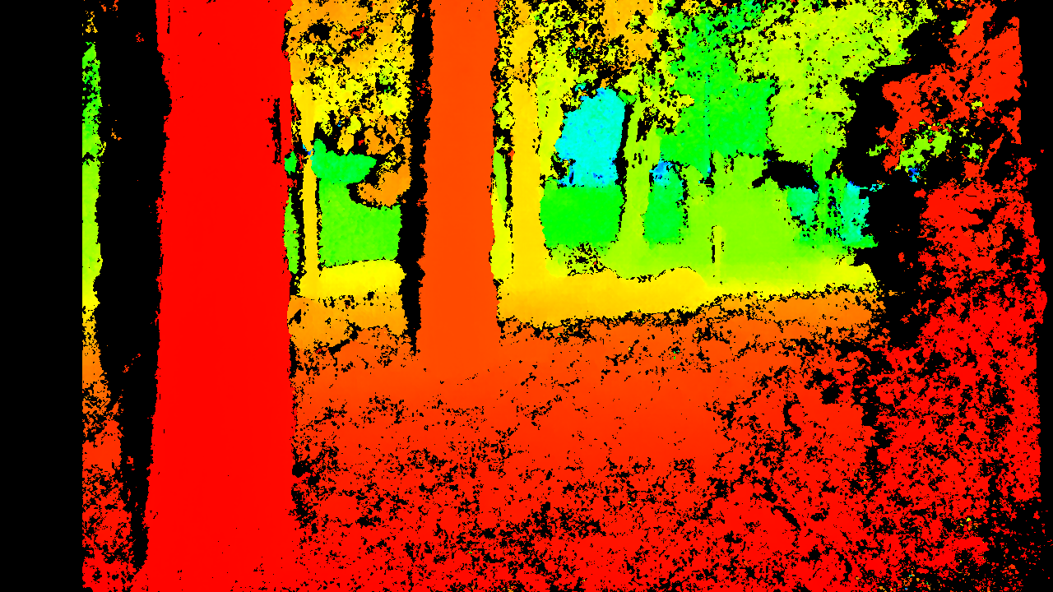

Figure 5: Final result of depth computation. *Left:* Input image to which the depth image is computed. *Right:* Final computed depth image. Areas of black show where the disparity could not be validated, i.e. where occlusions occurred.

### How to run the reference code

The reference code is tested and compiled on a Ubuntu 15.04. system and requires C++ 11, CMake (2.8.11 or higher), OpenCV and OpenMP.

To compile run the following from the source directory:

#> mkdir cmake\_build  
 #> cd cmake\_build  
 #> cmake ..  
 #> make –j4

The binary will be generated in a bin/ subdir from where the CMakeLists.txt lies. To run call the binary with the following parameters:

* *Frame1* – Path to input frame 1 (required)
* *Frame2* – Path to input frame 2 (required)
* *OutputWidth* – Width of output image (optional)
* *OutputHeight* – Height of output image (optional)

## Test data

For first tests and developments of the algorithm for the UAV use-case will be working a stereo dataset that was recorded using two GoPro-cameras mounted on a UAV. During this project we plan to attach two smaller, industrial cameras to the UAV and connect them directly via camera link to the Tulipp board.

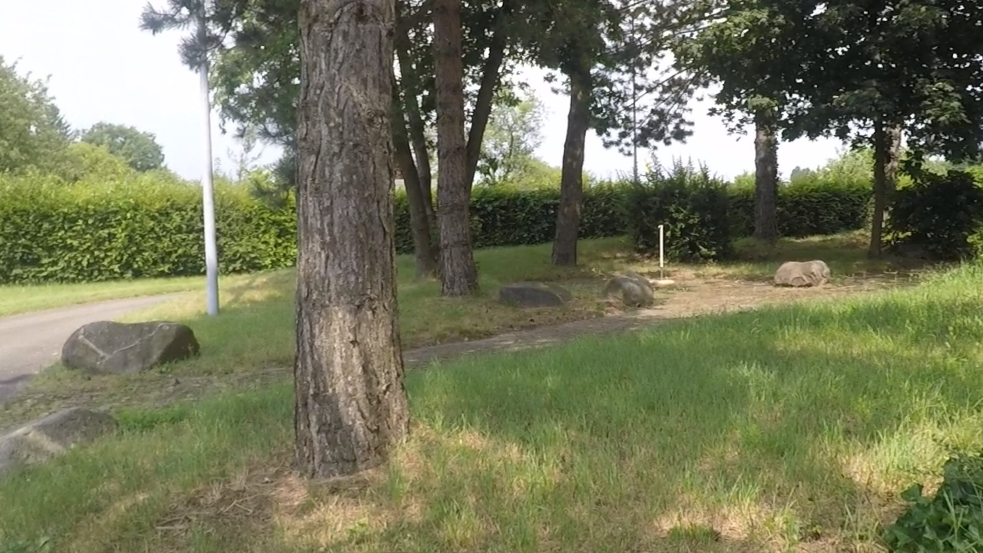 

Figure : Left and right stereo images of the input test data set. These images have been pre-rectified.

For the first test data set we provide a series of rectified stereo image as depicted in Figure 6. These images are transformed in such a way that it is only necessary to search along horizontal lines in order to calculate the depth. As by the end of this project the depth estimation is to take part on-board, the rectification process is also to be done by the Tulipp platform. Thus, by the end of the project the expected input data are two images straight from the cameras of a calibrated stereo rig.

As described in Chapter 2.4.1 the algorithm performs a stereo depth estimation on these input images. The expected output is a depth image to one of the input images holding per pixel information on how far the observed objects are located from the camera. Depending on the processing time the computation can be done on a down-sampled version of the input images (see Figure 7). However, a down-sampling will lead to a loss in detail, which could lead to a collision as a small obstacle could not be detected.

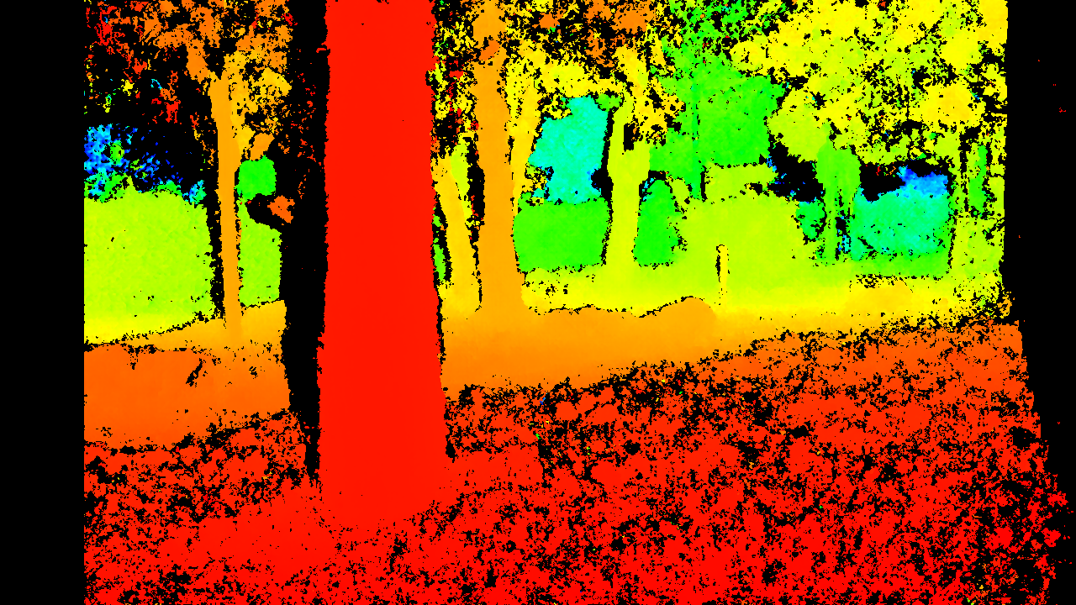 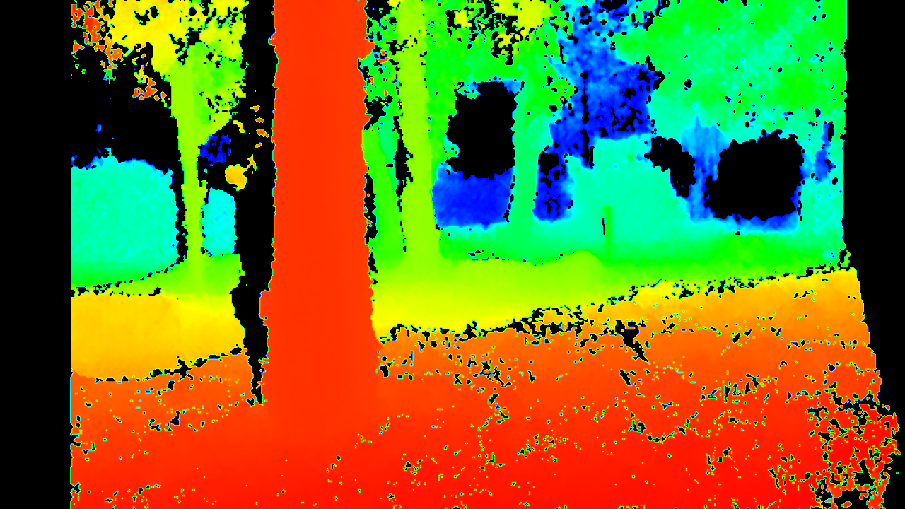 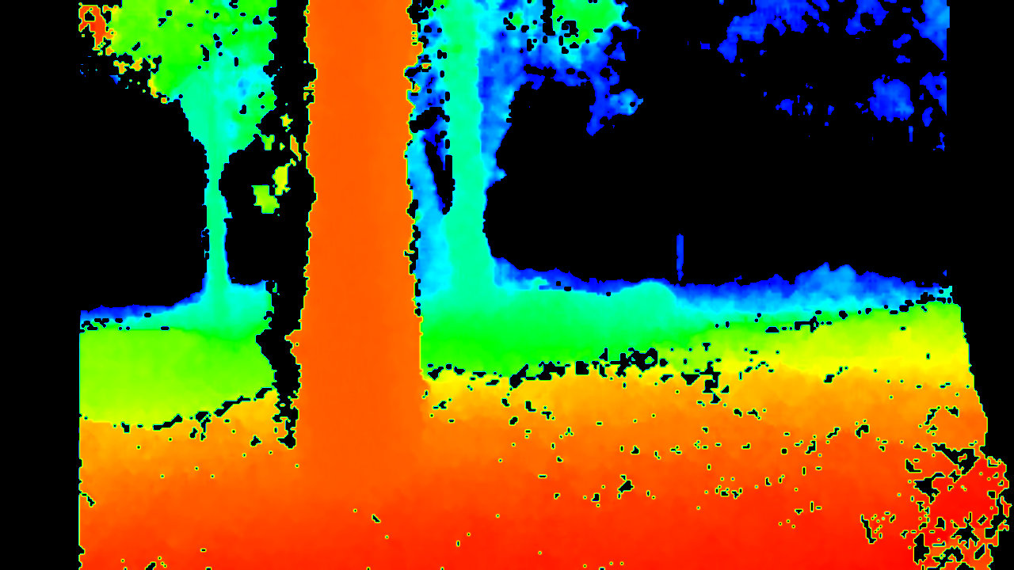 

Figure : Expected depth images as output of the algorithm in different sizes. Scaling factor from left to right: 1.0, 0.5, 0.3. Areas of black show where the disparity could not be validated, i.e. where occlusions occurred.

// TODO: to be removed ##############################################################

For a first test of the algorithm, we use data from the KITTI-Benchmark dataset (<http://www.cvlibs.net/datasets/kitti/> ). Although this data has been generated by a stereo rig mounted on a car, the data fits to the UAV use case. Moreover, reliable ground truth data for evaluation is provided, the benchmark allows comparison to other algorithms, and it is well known in the targeted computer vision community.

For further real-life tests, we will record data using two GoPro-cameras mounted on a UAV. Later on, we plan to attach two camera link cameras directly to the Tulipp module.

//#################################################################################

## Measures

The most important measures for the UAV use case are low latency and accuracy of the estimated depth images. Of course, energy efficiency is important as well for UAVs, as available power is very limited for UAVs, but the priority is lower compared to latency and accuracy. Therefore we will focus on the following questions:

* How many frames are calculated per second?
* How accurate are the depth estimates?
* Here we have a trade-off between more accurate estimates, e.g. by using higher resolution or more compute expensive calculations, and more processing time.

Table

|  |  |  |  |
| --- | --- | --- | --- |
| req.ID | Level | Title | Description |
| 1 | Must | Frame rate | @ resolution of 376x240 (1 byte per pixel):   * 10 fps 🡺 ~7 Mbits/sec |
| 2 | Must | Latency for small algo chain | @ resolution of 376x240 (1 byte per pixel):   * 10 msec between input of 1st pixels and output of last pixel. * Small algo chain = depth estimation by SGM-algorithm |
| 3 | Must | Latency for full algo chain | @ resolution of 376x240 (1 byte per pixel):   * 100 msec between input of 1st pixels and output of the new route to the UAV control unit * Full algo chain = see Chapter 2.2 |
| 4 | Must | Jitter | TBD |
| 5 | Must | Input/Output ports | Input port: 2 camera link  Output port: to be defined |
| 6 | Must | Computing precision | SGM-algorithm:  The depth estimates must be equal to C/C++ reference result @ +/- 1 LSB (level of quantification @ 8Bits) .  Note1: C/C++ reference code is based on 32 bits floating point operations.  Note2: algorithm implementation on Tulipp platform may be either in floating precision or fixed precision. |
| 7 | Must | Operating system and HLL for Algorithm | The use case must run on a Linux system, regular or soft real-time (preempt RT). |
| 6 | Want | Frame rate | @ resolution of 640 x 480 (1 byte per pixel) :   * 30 fps 🡺 ~73 Mbits/sec |
| 7 | Want | Latency for small algo chain | @ resolution of 640 x 480 (1 byte per pixel) :   * 3 msec between input of 1st pixels and output of last pixel. * Small algo chain = Clean stage, Spatial Gaussian, ABC/AGC, Clip |
| 8 | Want | Latency for full algo chain | @ resolution of 640 x 480 (1 byte per pixel):   * 10 msec between input of 1st pixels and output of the new route to the UAV control unit * Full algo chain = see Chapter 2.2 |

## Miscellaneous

As reference system, we take the obstacle avoidance system of Andrew J. Barry. He implemented a very fast obstacle avoidance system for UAVs at MIT in 2016 (High-Speed Autonomous Obstacle Avoidance with Pushbroom Stereo). The parameters of his hardware setup are:

* 2 x FMVU-03MTC-CS: 752 x 480 at 60 FPS (Firefly), operated at 376x240 at 120 FPS, pixel size 6 um
* M12 lens adapter: "3.6mm 92 Degree Wide Angle CCTV Camera IR Board Lens Focal for 1/3"" CCD"

The advantage of this Pushbroom algorithm is its fast computation. The main disadvantage is the poor resolution of the depth images. Systems that are more complex allow processing of dense depth images using SGM. However, these systems are currently realised on dedicated hardware (FPGA), which makes integration, coding and setup more difficult and expensive. This is the gap, which should be filled by the Tulipp UAV use case.

# Literature

|  |  |
| --- | --- |
| [1] | H. Hirschmueller, „Accurate and efficient stereo processing by semi-global matching and mutual information,“ in *IEEE Computer Society Conference on Computer Vision and Pattern Recognition (CVPR)*, 2005. |
| [2] | S. Birchfield und C. Tomasi, „Depth discontinuities by pixel-to-pixel stereo,“ *International Journal of Computer Vision (IJCV),* Bd. 35, Nr. 3, pp. 269-293, 1999. |